*LAB # 06*

searching in linear array

# *OBJECTIVE:*

*To find an element in linear array using linear search and binary search*

*LAB task*

1. *Declare an array of size 10 to store account balances. Initialize with values 0 to 1000000. Check all array if any value is less than 10000. Show message:*

*Account No. Low Balance*

*Account No. Low Balance*

**Code:**

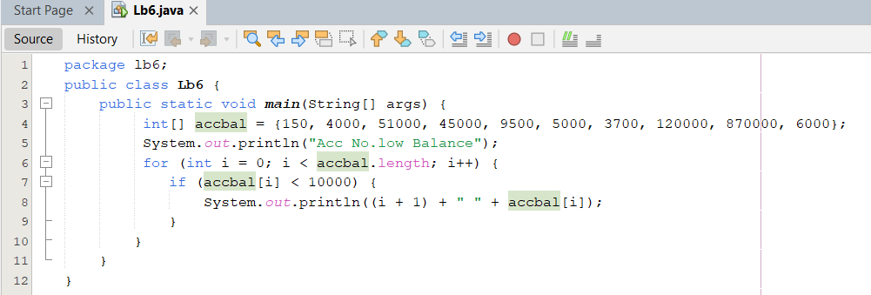

**Output:**

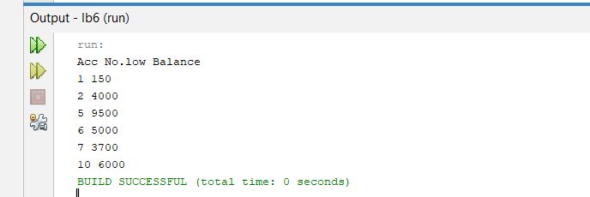

1. *Write a program to search in array using Array built-in class.*

**Code:**

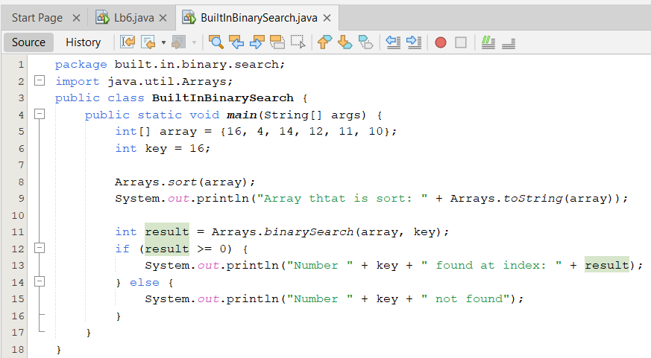

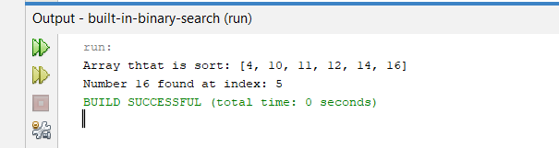

1. *Given an unsorted array arr of integers, find the smallest positive integer that is* ***missing*** *from the array. You need to implement this using* ***binary search****. The array can contain both negative numbers and positive numbers, and you can assume that the array does not have duplicates.*

**Code:**

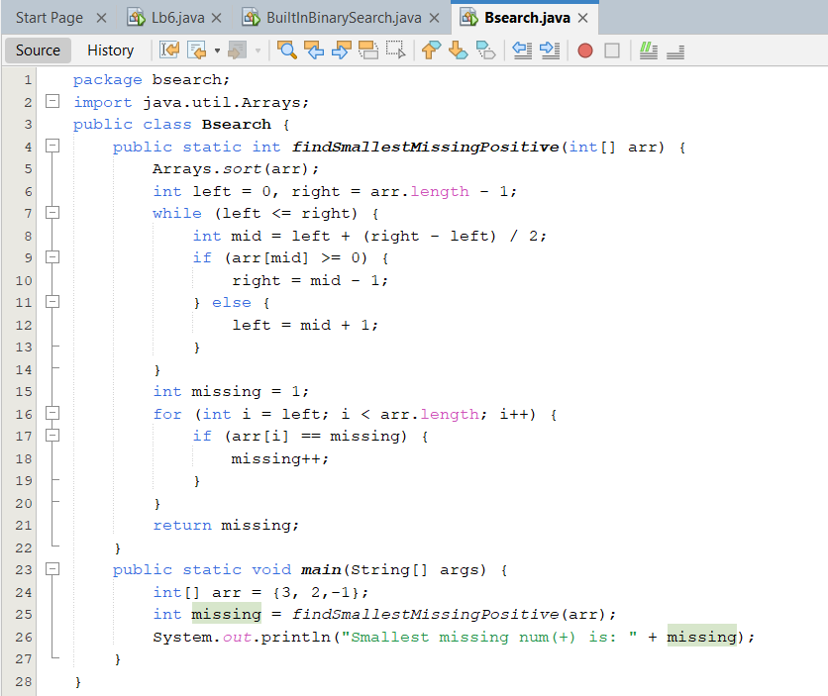

**Output:**

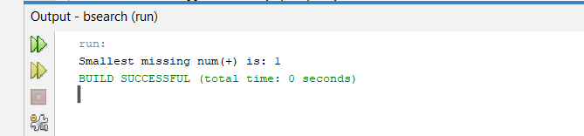

1. *You are given a sorted array arr[] and a target element target. Your task is to find the* ***first occurrence*** *of the target in the array using binary search. If the target is not found, return -1..*

**Code:**

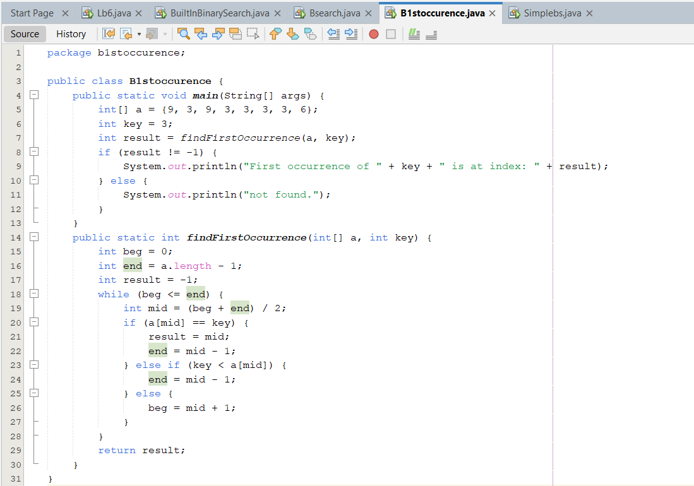

**Output:**

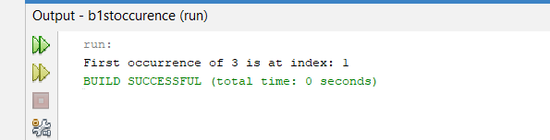

*HOME task*

1. *Write a program initializing array of size 20 and search an element using binary search.*

**Code:**

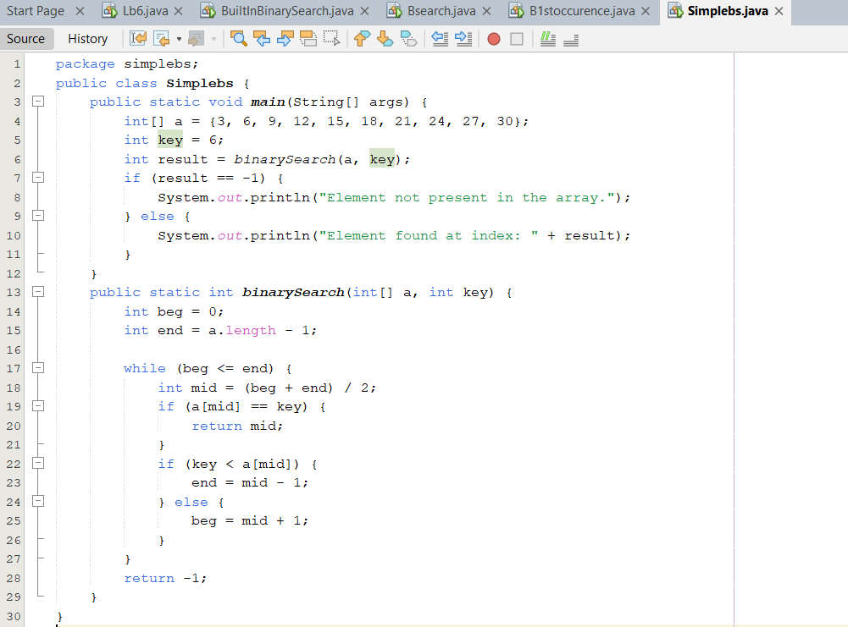

**Output:**

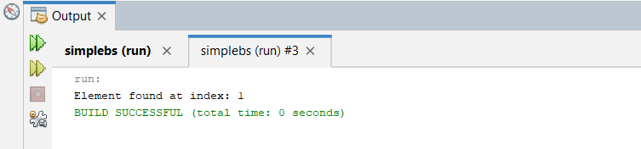

1. *Write a function called occurrences that, given an array of numbers A, prints all the distinct values in A each followed by its number of occurrences.*

*For example, if A = (28, 1, 0, 1, 0, 3, 4, 0, 0, 3), the function should output the following five lines (here separated by a semicolon) “28 1; 1 2; 0 4; 3 2; 4 1”.*

**Code:**

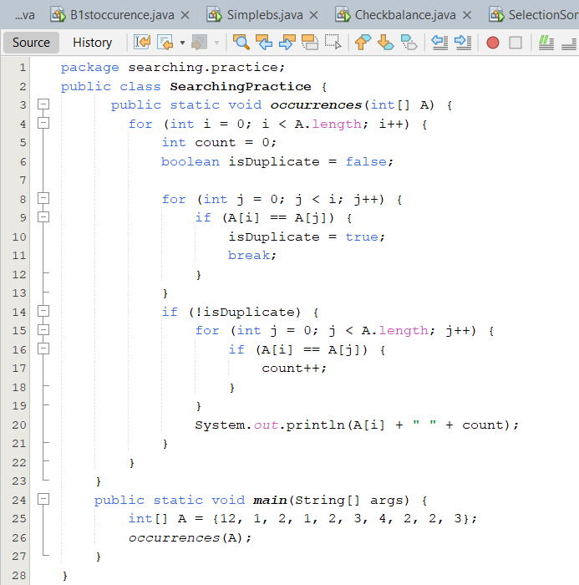

**Output:**

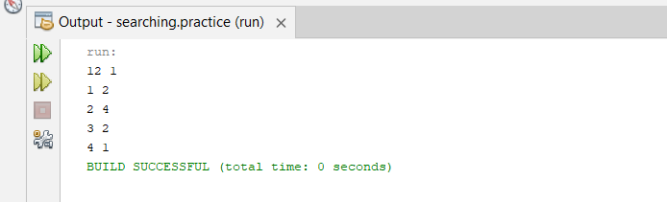

1. *Assume a bank's system needs to identify accounts with critically low balances and alert the user. Test the function with various balance values to ensure it correctly identifies all accounts below the threshold*

**Code:**

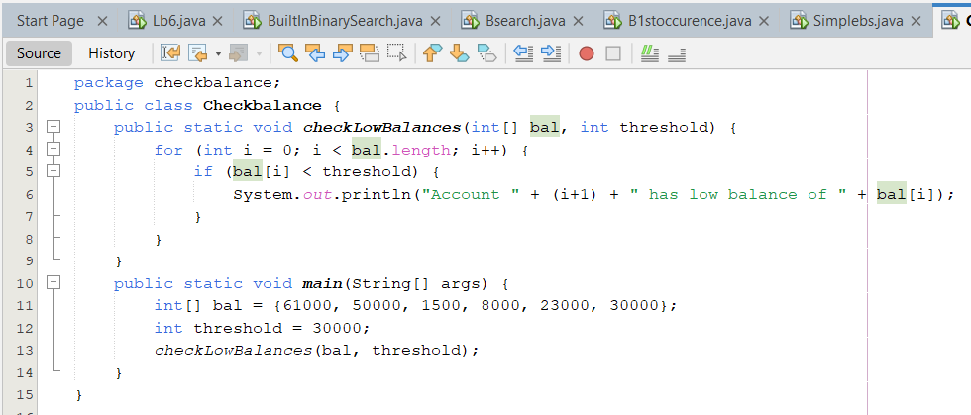

**Output:**

